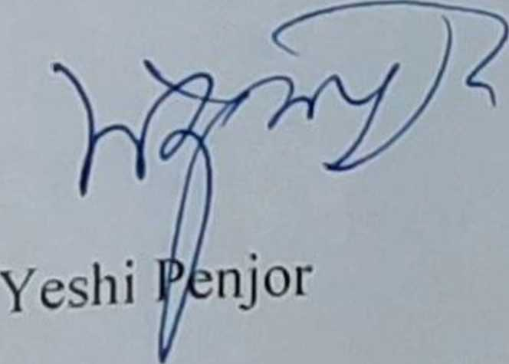

Minister ppD/lFS/05/

8 September 2021

Yours sincerely,

ROYAL GOVERNMENT OF BHUTAN

Ministry of Agriculture and Forests

Thimphu : Bhutan

* 0 the attention of the GAFSP Coordination Unit,

**Subject: Submission of the Country Proposal for the project Building Resilient Commercial Smallholder Agriculture (BRECSA)**

I write with reference to the sixth GAFSP call for proposals of 20 May 2021 in the context of the ongoing COVID 19 global pandemic. I am pleased to submit to your attention on behalf of the Royal Government of Bhutan (RGoB) a grant funding proposal tilled Building Resilient Commercial Smallholder Agriculture (BRECSA) to be implemented in the Kingdom of Bhutan.

1 he proposal addresses public sector investment priorities and enables private sector development opportunities. The proposal aims at meeting the country’s medium and long-term COVID-19 response efforts for ‘"building back better", a more sustainable, inclusive, and resilient agriculture and food system in context of a changing climate. The proposal is consistent with the RGoB’s key agricultural policies and programmes and directly addresses COVID-19 recovery priorities.

With this letter I hereby confirm that the Ministry of Agriculture and Forests of the Royal Government of Bhutan (MOAF) has requested the International Fund for Agricultural Development (IFAD) to function as the Investment Supervising Entity and the World Food Programme (WFP) as Supervising Entity for Technical Assistance. The MOAF will be the lead implementing agency for this project.

1 would like to take this opportunity to thank the GAFSP Coordination Unit for launching this timely call for proposals as it goes towards addressing a critical need in the Kingdom of Bhutan. If the RGoB’s proposal is approved it will greatly contribute to building a resilient, commercially oriented, and productive agriculture sector that alleviates poverty and consolidates food and nutrition security.

PHONE: +975-2-322482, 322129(0) FAX: +975-323153